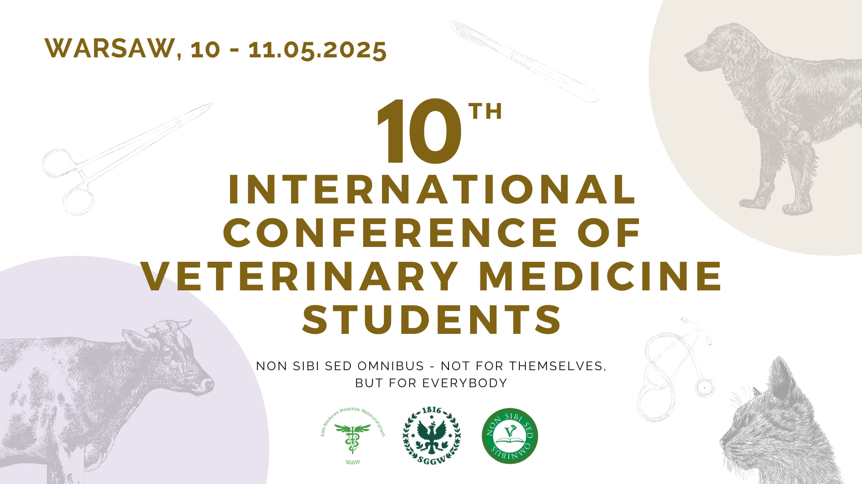

Abstract submission
Abstract must be written in English and be no more than 500 words. Use Times New Roman 12-point font. Titles should be written in italics. Title and author(s) should be centred on the page and name(s) of the author(s) should be bolded. The presenting author`s name should be underlined. A blank line should be inserted between title and author(s) and affiliation(s). For further details see the example.

title title title title title title title title title title
Author 1¹, Author 2²
1). University of research center of author 1
2). University of research center of author 2

Abstract

Lorem ipsum dolor sit amet, consectetur adipiscing elit, sed do eiusmod tempor incididunt ut labore et dolore magna aliqua.
Ut enim ad minim veniam, quis nostrud exercitation ullamco laboris nisi ut aliquip ex ea commodo consequat. Duis aute irure dolor in reprehenderit in voluptate velit esse cillum dolore eu fugiat nulla pariatur.
Excepteur sint occaecat cupidatat non proident, sunt in culpa qui officia deserunt mollit anim id est laborum.

This study was supported through funding from…………………………………………………………………………………………..

The abstract should be send via application form until 7th April 2025.
Information on the acceptance of the abstracts: after 15th April 2025.
All accepted abstracts will be published in Conference materials.

